**SQL Coding Challenge**

**#Database creation**

CREATE DATABASE Car_Rental_System;

use Car_Rental_System;

**#Vehicle Table**

CREATE TABLE vehicle (

vehicle_id INT PRIMARY KEY IDENTITY(1,1),

make VARCHAR(50),

model VARCHAR(50),

year INT,

daily_rate DECIMAL(10, 2),

status VARCHAR(20) CHECK (status IN ('available', 'notavailable')),

passenger_capacity INT,

engine_capacity DECIMAL(5, 2)

);

INSERT INTO vehicle (make, model, year, daily_rate, status, passenger_capacity, engine_capacity) VALUES

('Nissan', 'Altima', 2022, 32.00, 'available', 5, 2.5),

('Chevrolet', 'Cruze', 2021, 28.00, 'notavailable', 5, 1.8),

('BMW', 'X5', 2023, 70.00, 'available', 5, 3.0),

('Mercedes', 'C-Class', 2022, 75.00, 'available', 5, 2.0),

('Audi', 'A4', 2021, 68.00, 'notavailable', 5, 2.0),

('Kia', 'Seltos', 2020, 30.00, 'available', 5, 1.5),

('Volkswagen', 'Jetta', 2023, 34.00, 'available', 5, 1.4),

('Renault', 'Duster', 2021, 27.00, 'notavailable', 5, 1.6),

('Jeep', 'Compass', 2023, 50.00, 'available', 5, 2.0),

('Mazda', 'CX-5', 2022, 36.00, 'available', 5, 2.5),

('Skoda', 'Octavia', 2020, 33.00, 'available', 5, 1.8),

('Peugeot', '208', 2021, 26.00, 'available', 5, 1.2),

('Fiat', 'Punto', 2020, 22.00, 'available', 5, 1.3),

('Volvo', 'XC60', 2023, 65.00, 'available', 5, 2.0),

('Suzuki', 'Swift', 2022, 24.00, 'available', 5, 1.2),

('Toyota', 'Yaris', 2021, 27.00, 'available', 5, 1.3),

('Honda', 'Accord', 2023, 45.00, 'available', 5, 2.0),

('Ford', 'Focus', 2020, 29.00, 'available', 5, 1.6),

('Hyundai', 'Elantra', 2022, 33.00, 'available', 5, 1.8),

('MG', 'Hector', 2023, 50.00, 'available', 5, 2.0);

**#Customer Table**

CREATE TABLE customer (

customer_id INT PRIMARY KEY IDENTITY(1,1),

first_name VARCHAR(50),

last_name VARCHAR(50),

email VARCHAR(100) UNIQUE,

phone_number VARCHAR(20)

);

INSERT INTO customer (first_name, last_name, email, phone_number) VALUES

('Alice', 'Smith', 'alice@example.com', '1234567890'),

('Bob', 'Johnson', 'bob@example.com', '0987654321'),

('Charlie', 'Brown', 'charlie@example.com', '1112223333'),

('Diana', 'Prince', 'diana@example.com', '4445556666'),

('Evan', 'Williams', 'evan@example.com', '7778889999'),

('Fiona', 'Garcia', 'fiona@example.com', '1111111111'),

('George', 'Martin', 'george@example.com', '2222222222'),

('Hannah', 'Lee', 'hannah@example.com', '3333333333'),

('Ian', 'Wright', 'ian@example.com', '4444444444'),

('Jane', 'Doe', 'jane@example.com', '5555555555'),

('Kyle', 'Young', 'kyle@example.com', '6666666666'),

('Laura', 'Green', 'laura@example.com', '7777777777'),

('Mike', 'Taylor', 'mike@example.com', '8888888888'),

('Nina', 'Patel', 'nina@example.com', '9999999999'),

('Oscar', 'Clark', 'oscar@example.com', '1010101010'),

('Paula', 'Hill', 'paula@example.com', '1212121212'),

('Quentin', 'Wood', 'quentin@example.com', '1313131313'),

('Rachel', 'King', 'rachel@example.com', '1414141414'),

('Steve', 'Adams', 'steve@example.com', '1515151515'),

('Tina', 'Lopez', 'tina@example.com', '1616161616');

**#Lease Table**

CREATE TABLE lease (

lease_id INT PRIMARY KEY IDENTITY(1,1),

vehicle_id INT,

customer_id INT,

start_date DATE,

end_date DATE,

type VARCHAR(10) CHECK (type IN ('daily', 'monthly')),

FOREIGN KEY (vehicle_id) REFERENCES vehicle(vehicle_id),

FOREIGN KEY (customer_id) REFERENCES customer(customer_id)

);

INSERT INTO lease (vehicle_id, customer_id, start_date, end_date, type) VALUES

(1, 1, '2025-06-01', '2025-06-05', 'daily'),

(2, 2, '2025-06-10', '2025-07-10', 'monthly'),

(3, 3, '2025-06-15', '2025-06-20', 'daily'),

(4, 4, '2025-06-05', '2025-07-05', 'monthly'),

(5, 5, '2025-06-25', '2025-06-30', 'daily'),

(6, 6, '2025-07-01', '2025-07-10', 'daily'),

(7, 7, '2025-07-01', '2025-08-01', 'monthly'),

(8, 8, '2025-07-02', '2025-07-07', 'daily'),

(9, 9, '2025-07-03', '2025-08-03', 'monthly'),

(10, 10, '2025-07-04', '2025-07-09', 'daily'),

(11, 11, '2025-07-05', '2025-08-05', 'monthly'),

(12, 12, '2025-07-06', '2025-07-11', 'daily'),

(13, 13, '2025-07-07', '2025-08-07', 'monthly'),

(14, 14, '2025-07-08', '2025-07-13', 'daily'),

(15, 15, '2025-07-09', '2025-08-09', 'monthly'),

(16, 16, '2025-07-10', '2025-07-15', 'daily'),

(17, 17, '2025-07-11', '2025-08-11', 'monthly'),

(18, 18, '2025-07-12', '2025-07-17', 'daily'),

(19, 19, '2025-07-13', '2025-08-13', 'monthly'),

(20, 20, '2025-07-14', '2025-07-19', 'daily');

**#Payment Table**

CREATE TABLE payment (

payment_id INT PRIMARY KEY IDENTITY(1,1),

lease_id INT,

payment_date DATE,

amount DECIMAL(10, 2),

FOREIGN KEY (lease_id) REFERENCES lease(lease_id)

);

INSERT INTO payment (lease_id, payment_date, amount) VALUES

(1, '2025-06-01', 100.00),

(2, '2025-06-10', 1050.00),

(3, '2025-06-15', 200.00),

(4, '2025-06-05', 1500.00),

(5, '2025-06-25', 125.00),

(6, '2025-07-01', 180.00),

(7, '2025-07-01', 1020.00),

(8, '2025-07-02', 150.00),

(9, '2025-07-03', 1100.00),

(10, '2025-07-04', 160.00),

(11, '2025-07-05', 1300.00),

(12, '2025-07-06', 170.00),

(13, '2025-07-07', 1250.00),

(14, '2025-07-08', 175.00),

(15, '2025-07-09', 1400.00),

(16, '2025-07-10', 185.00),

(17, '2025-07-11', 1350.00),

(18, '2025-07-12', 190.00),

(19, '2025-07-13', 1450.00),

(20, '2025-07-14', 195.00);

**-- Average Payment Per Vehicle**

select v.vehicle_id, v.make + ' ' + v.model as vehicle_name,avg(p.amount) as avg_payment

from vehicle v join lease l on v.vehicle_id = l.vehicle_id join payment p on l.lease_id = p.lease_id

group by v.vehicle_id, v.make, v.model;

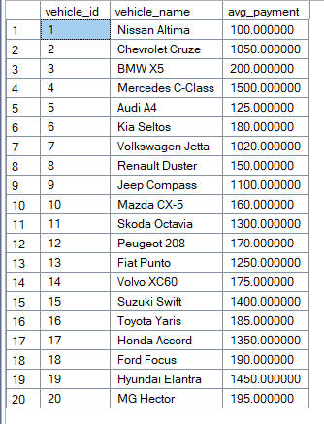

**-- Total Leases Per Customer**

select c.customer_id,c.first_name + ' ' + c.last_name as customer_name, count(l.lease_id) as total_leases

from customer c join lease l on c.customer_id = l.customer_id

group by c.customer_id, c.first_name, c.last_name;

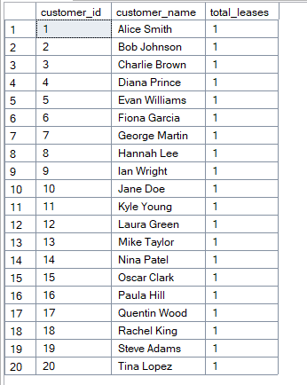

**-- Total Amount Paid Per Lease**

select l.lease_id,l.type,sum(p.amount) as total_paid

from lease l join payment p on l.lease_id = p.lease_id

group by l.lease_id, l.type;

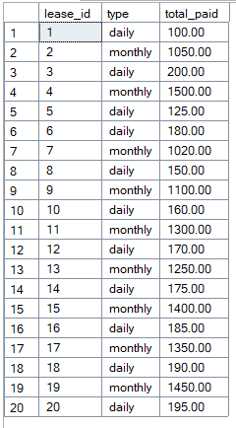

**-- Max, Min Payment Grouped By Lease Type**

select l.type,max(p.amount) as max_payment,min(p.amount) as min_payment

from payment p join lease l on p.lease_id = l.lease_id

group by l.type;

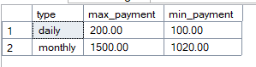

**-- Avg Payment Grouped By Lease Type**

select l.type,avg(p.amount) as avg_payment

from payment p join lease l on p.lease_id = l.lease_id

group by l.type;

